Master Document — Team Page Mock Sprint

[Login Restyling Bootstrap] Task 1 —Write Requirements: Team Page & Login Styling
Role | BA – Shehryar Shaukat | Date | Monday, 10 August 2026
Completion comment
Done: Completed and refined the Team Page and Login Styling requirements, including required team member fields, display/validation rules, styling-only login scope, authentication behaviour, redirect/access requirements, edge cases, and acceptance criteria.
Deliverable: Business Requirements for Team Page and Login Styling
Note for next role: Requirements have been reviewed and refined by the PM and are ready for UX review. Login work is styling-only and the existing authentication, validation, and session behaviour should not be changed.
Git URL: https://github.com/tuanlam05/rmit-capstone/commit/ec58821659758db6cb40bc048fc468a88e7d749e

[Login Restyling Bootstrap] Task 2 — Design Login Style & Team Page Layout
Role | UX – Andi Jagila | Date | Monday, 10 August 2026
Completion comment
Done: Completed restyled mockups for login page and team page
Deliverable: Design Login Style & Team Page Layout
Note for next role: Placeholders used instead of real member data, please swap in real content when available. Followed repo's docs/DESIGN.md for colours/fonts/spacing.
Edge cases handled:
- Missing photo: initials fill the placeholder
- Long name: wraps, doesn't break the card
- Long blurb: line-clamp-3 + "Read more"
- Missing role/blurb: field collapses, card keeps shape
- Odd photo dimensions: object-cover, centre crop
- Login errors: validation + incorrect credential messages both stay visible on the form
Git URL (commit): https://github.com/tuanlam05/rmit-capstone/commit/7f018a3d833994f433ca0bfc818c193d33e8015f
Style Guide
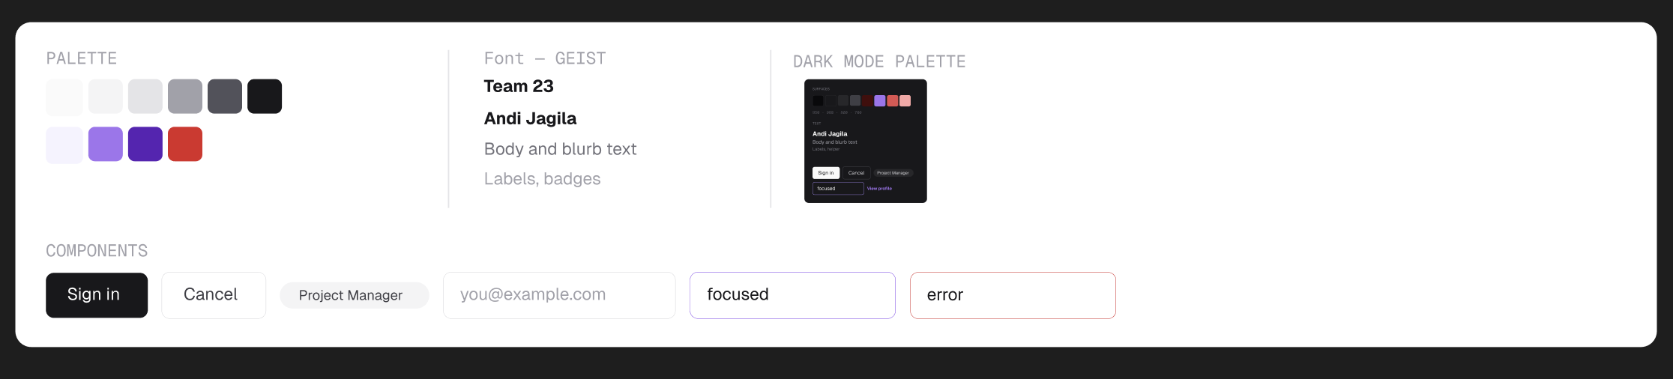
Sign In Page – Light mode
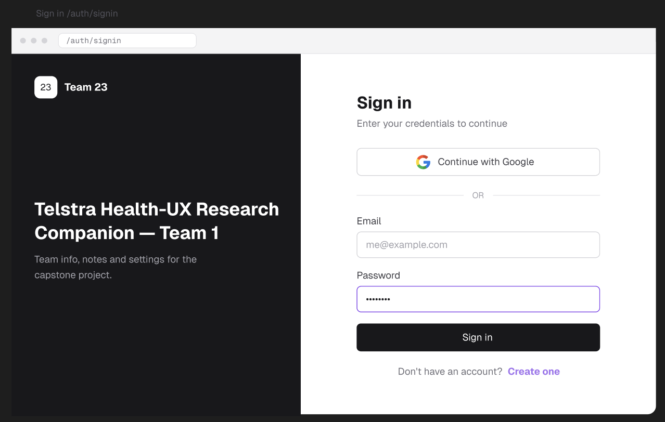

Sign in page – Dark mode
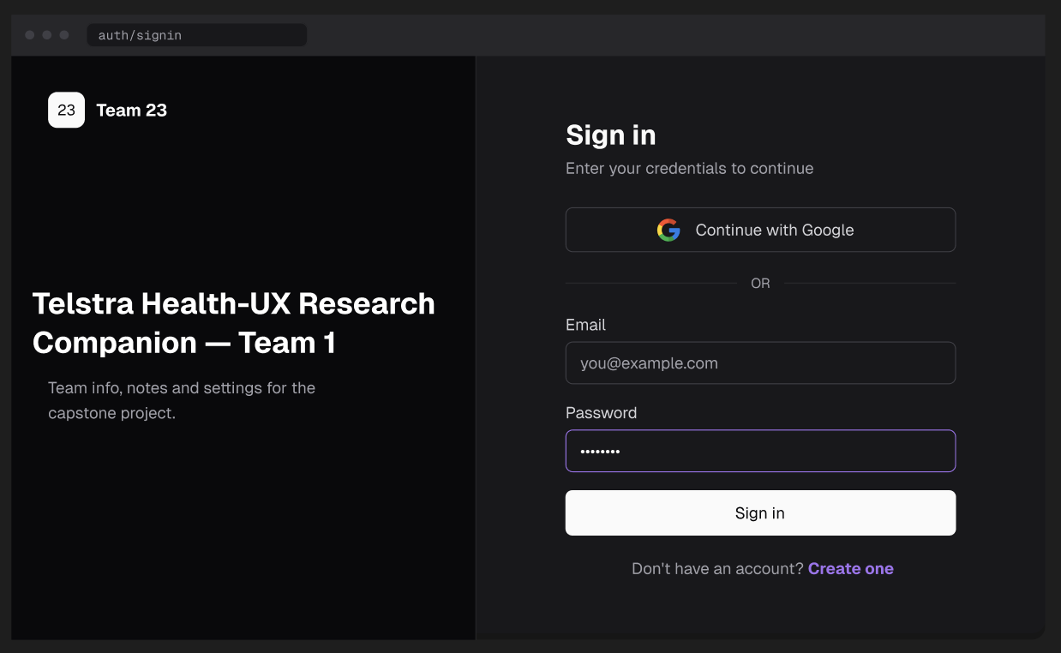

Sign in page – error state - light mode
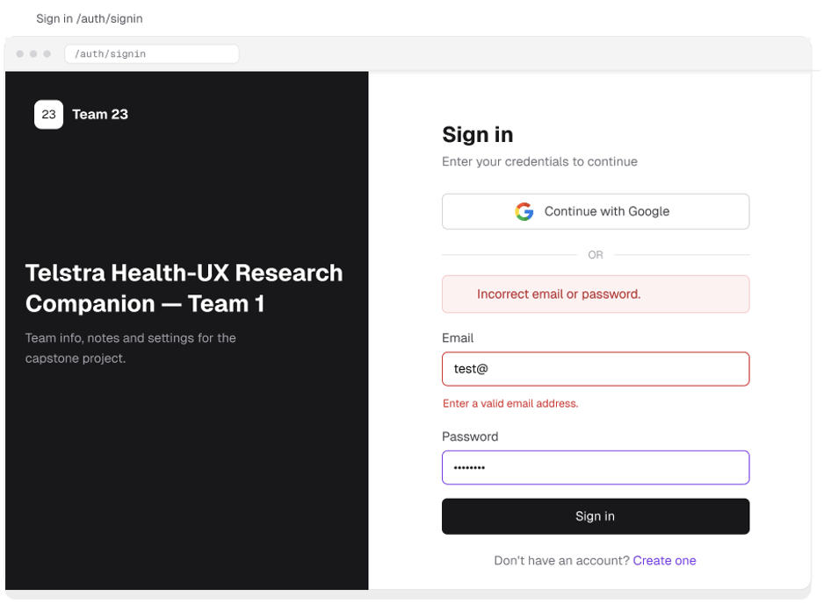

Sign in page – error state - dark mode
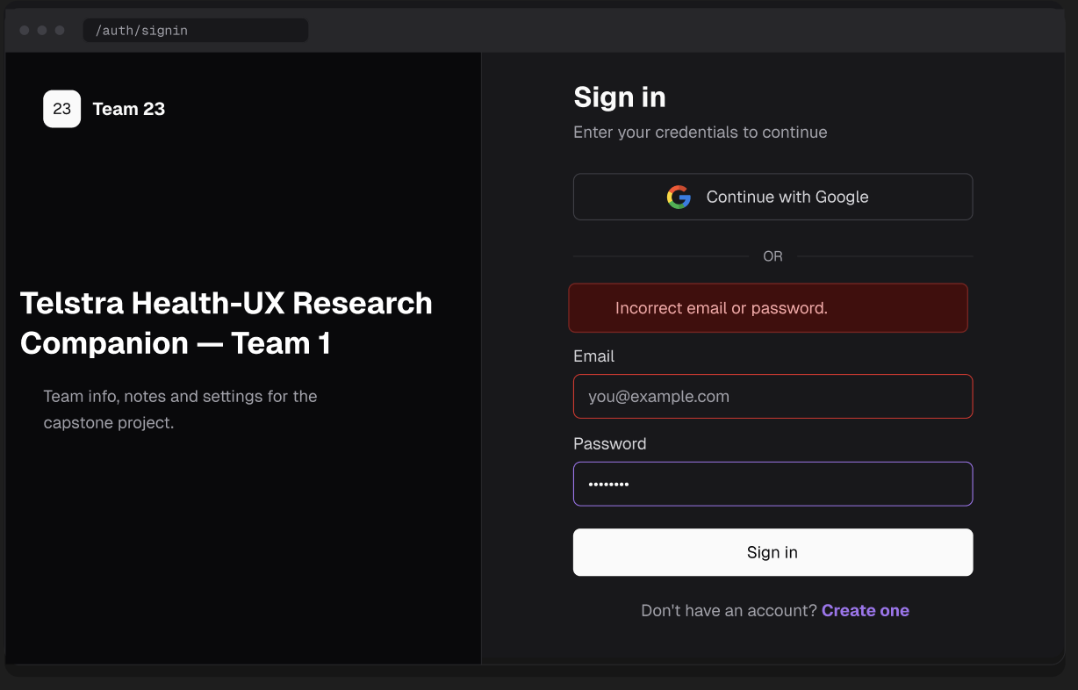

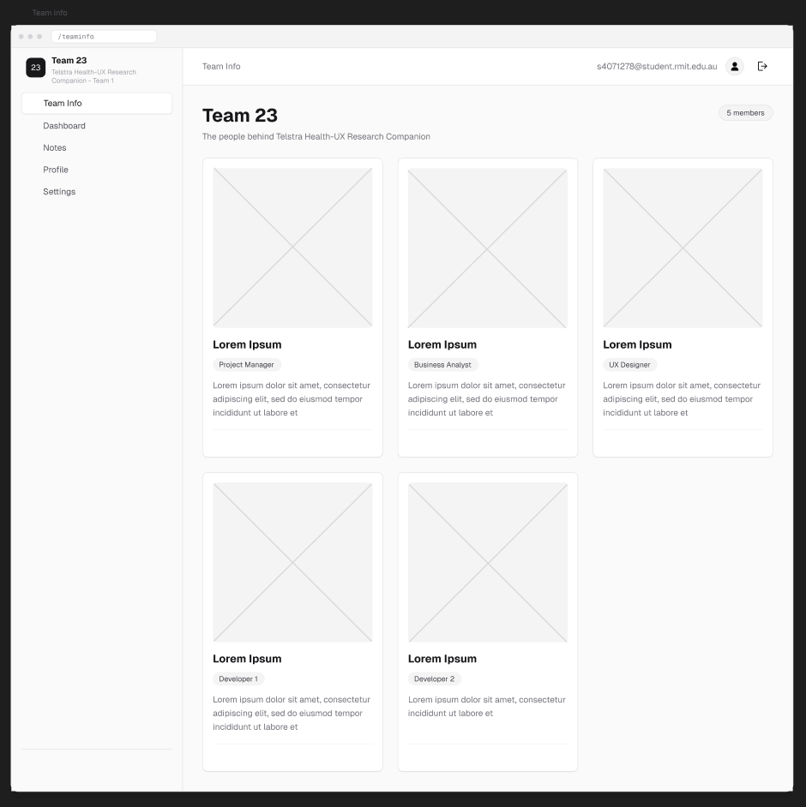
Team page – light mode

Team page – dark mode
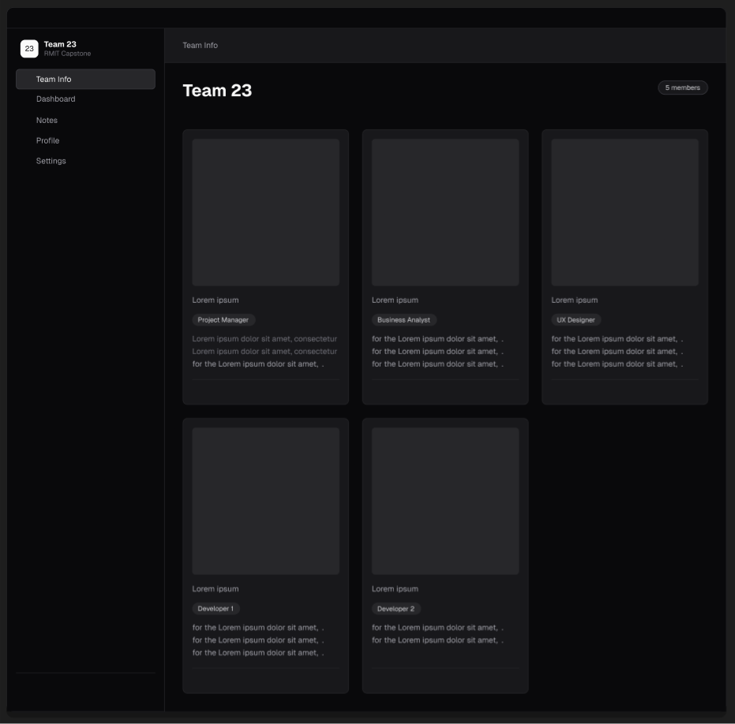

Edge cases – light mode
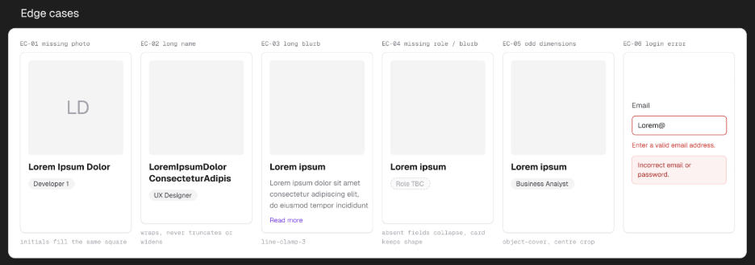
Edge cases – dark mode
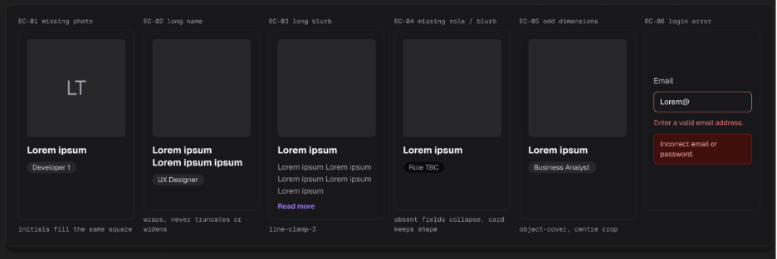

Unauthenticated direct team page access
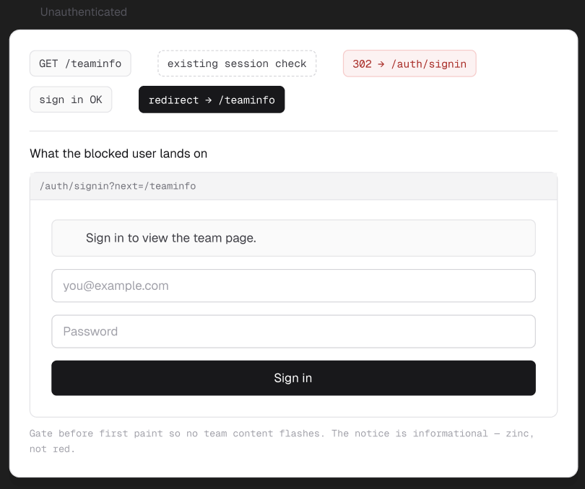

[Login Restyling Bootstrap] Task 3 — Validate Design Against Requirements
Role | BA – Shehryar Shaukat | Date | Tuesday, 11 August 2026
Completion comment
Done: Validated the final UX design against the approved BA requirements. All required fields were checked, the login scope was confirmed unchanged, any identified gaps were resolved with UX, and the final design was formally approved.
Deliverable: Design Login Style & Team Page Layout
Note for next role: The final UX design has been validated against the approved requirements and is ready for development. Please implement the approved Sign In and Team Page designs while keeping the existing authentication logic, validation, and session behaviour unchanged.
Git URL: https://github.com/tuanlam05/rmit-capstone/commit/7f018a3d833994f433ca0bfc818c193d33e8015f

[Login Restyling Bootstrap] Task 4 — Style Login Page
Role | Dev 1 – Manh Tuan Lam | Date | Tuesday, 11 August 2026
Completion comment
Done: restyled the existing login page to match the approved visual design, without changing authentication, validation, or session handling.
Deliverable: https://github.com/tuanlam05/rmit-capstone
Note for next role: styling-only changes. existing authentication logic, validation, and session handling were left unchanged. No known edge cases or out-of-scope changes
Git URL (commit): https://github.com/tuanlam05/rmit-capstone/commit/72e1402d0a414c260f6ee9c3b99c38aeebd1d5a3

REAL OUTPUT — rendered login page

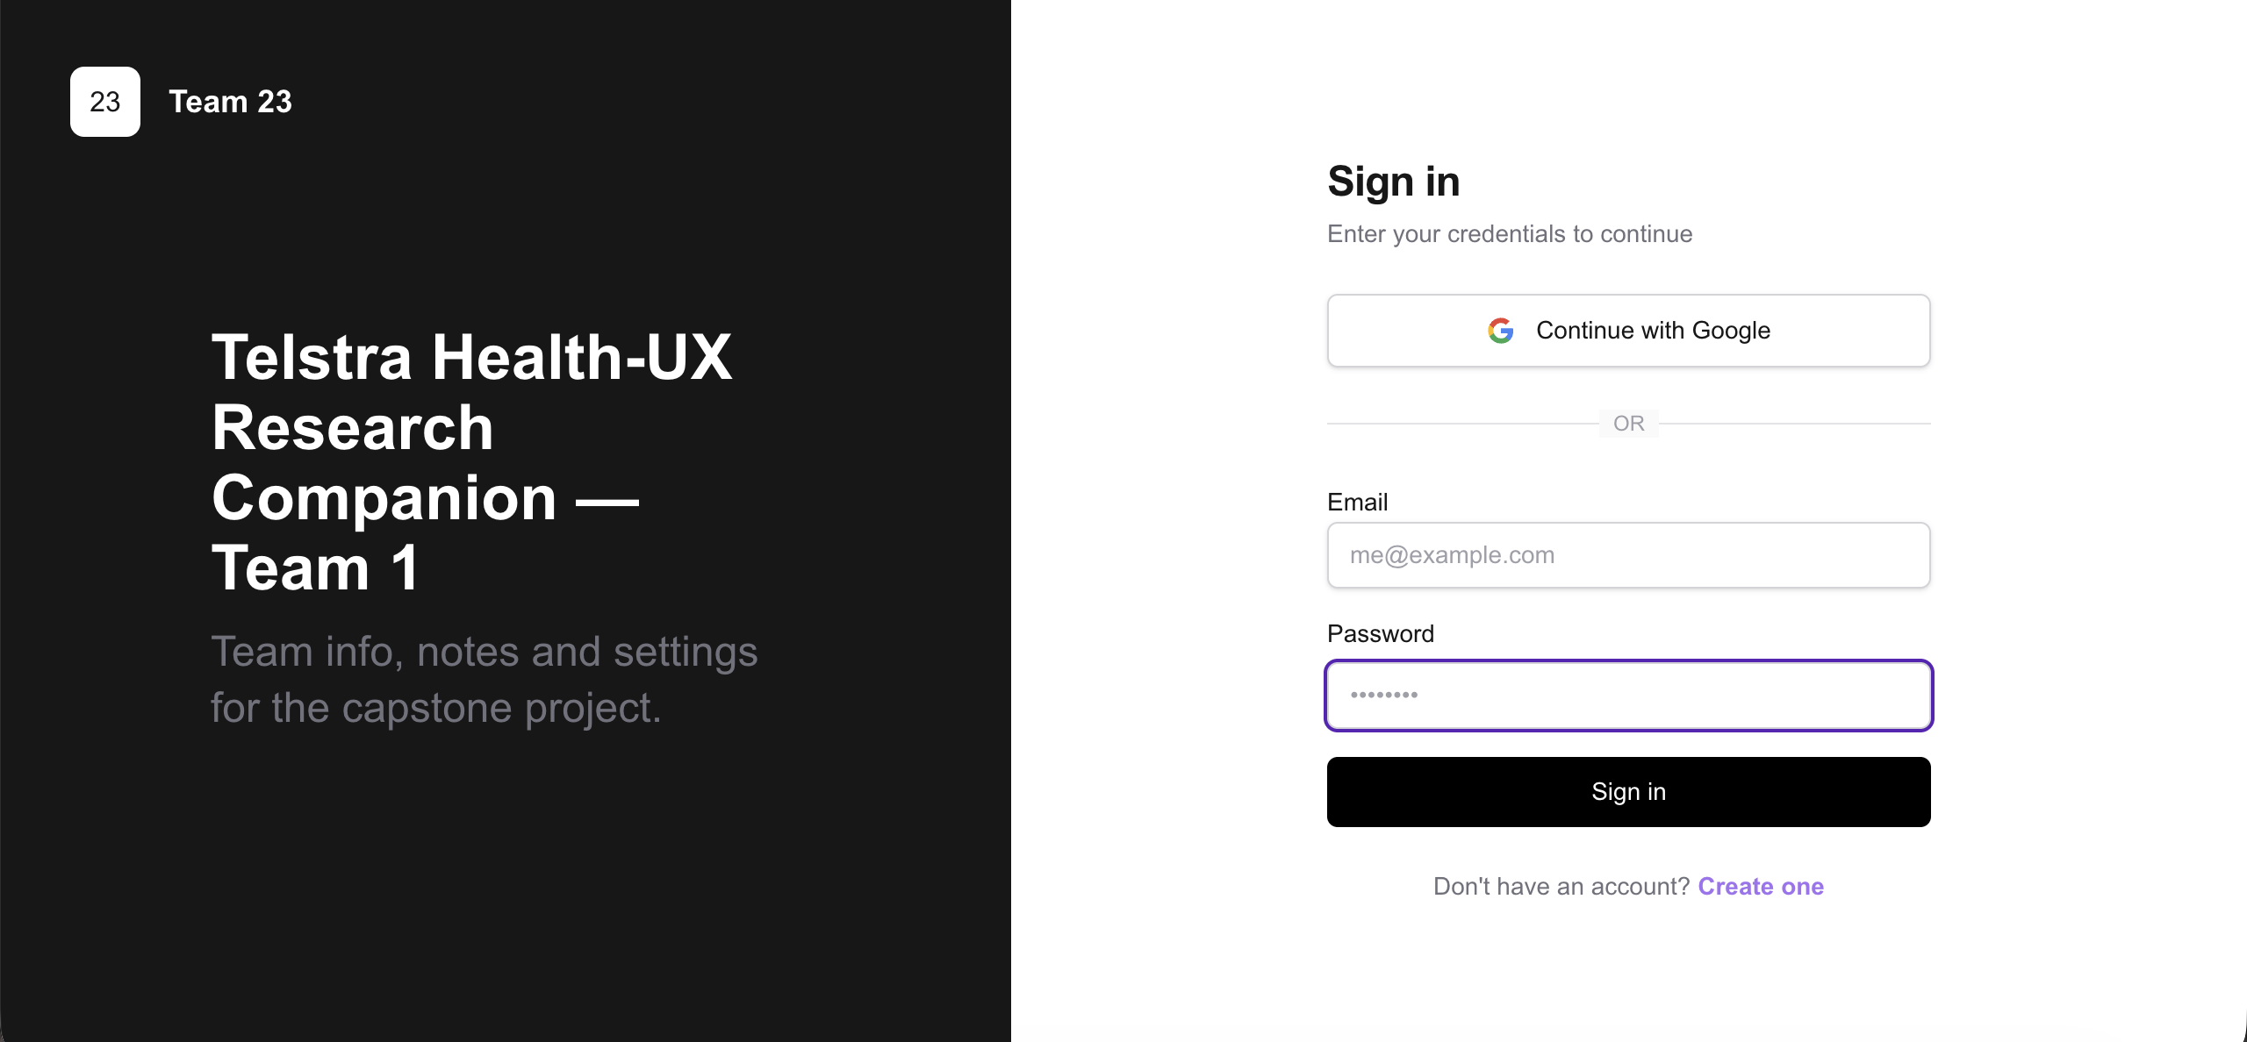

[Login Restyling Bootstrap] Task 5 — Build Team Page & Auth Redirect
Role | Dev 1 – Manh Tuan Lam | Date | Tuesday, 10 August 2026
Completion comment
Done: built the team page with the approved name, member cards, photos, roles, and blurbs; successful login now redirects to the team page, which is protected behind authentication.
Deliverable: https://github.com/tuanlam05/rmit-capstone
Note for next role: team page and auth redirect are implemented. Unauthenticated users are redirected away from the team page. Existing authentication and session handling were left unchanged.
Git URL (commit): https://github.com/tuanlam05/rmit-capstone/commit/87dce8eea8d7bd07117613628d736298d8f53739
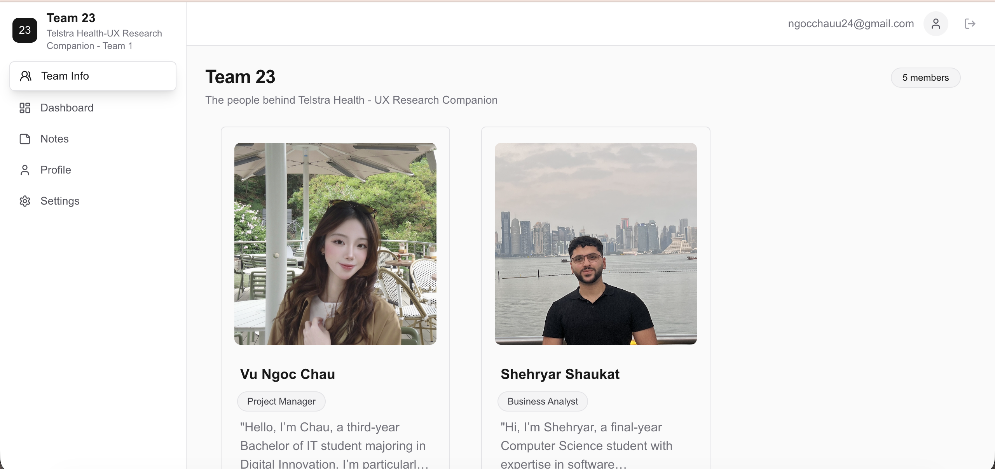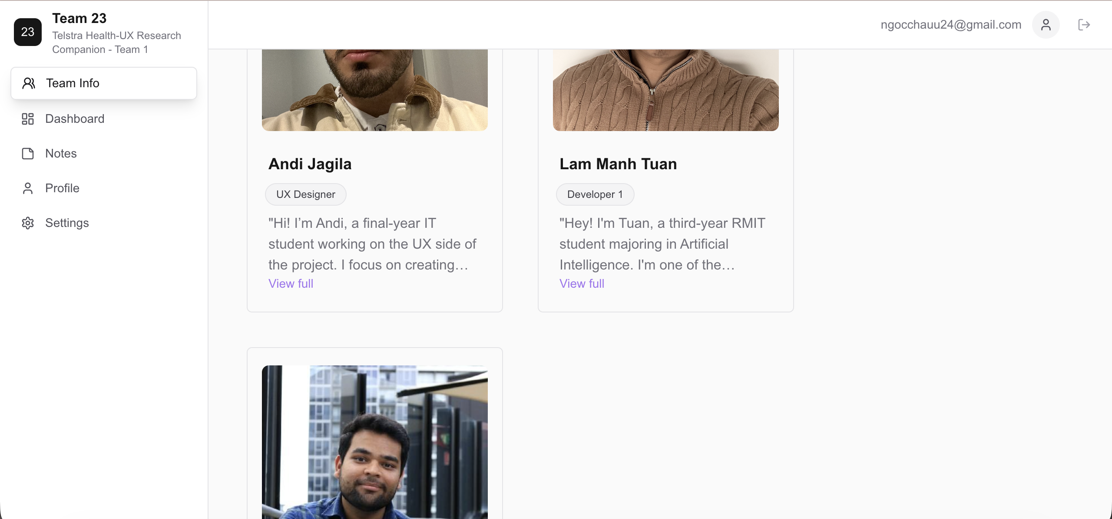

[Login Restyling Bootstrap] Task 6 — Test Login → Redirect → Team Page Flow
Role | Dev 2 – Rishi Sood | Date | Thursday, 13 August 2026
Completion comment
Done: Completed manual testing on the login interface and Team Info page (deployed URL) including proper redirects and verified all required content including member cards and UX elements to be complete.
Deliverable: https://github.com/tuanlam05/rmit-capstone
Note for next role: Login has been tested E2E, redirects function properly, member blurbs have some grammatical and punctuation errors. This has been fixed.
Git URL (test script): https://github.com/tuanlam05/rmit-capstone/commit/1038bfffe7d9c32082e87c880fa8017c1816d363

[Login Restyling Bootstrap] Task 7 — Test Edge Cases & Log Bugs
Role | Dev 2 – Rishi Sood | Date | Thursday, 13 August 2026
Completion comment
Done: Created unit tests for invalid logins and unauthorised team-page access redirect. Performed manual testing for missing-photo and long-blurb edge cases, and logged any bugs found in the Manual Testing Record.
Deliverables:
Manual Testing Record: https://drive.google.com/file/d/1QQ-090ffr2imqvjXb8Bza9iUQ1DyxL7P/view?usp=sharing
Project Repo - https://github.com/tuanlam05/rmit-capstone
Note for next role: The unit tests created for invalid login and redirect testing were successful. One bug was observed in manual testing where a long blurb will extend out of the member card when viewed in full. This has been fixed.
Git URL (test script): https://github.com/tuanlam05/rmit-capstone/commit/8e65d090b763485287951e0a061f154a9c8542d3
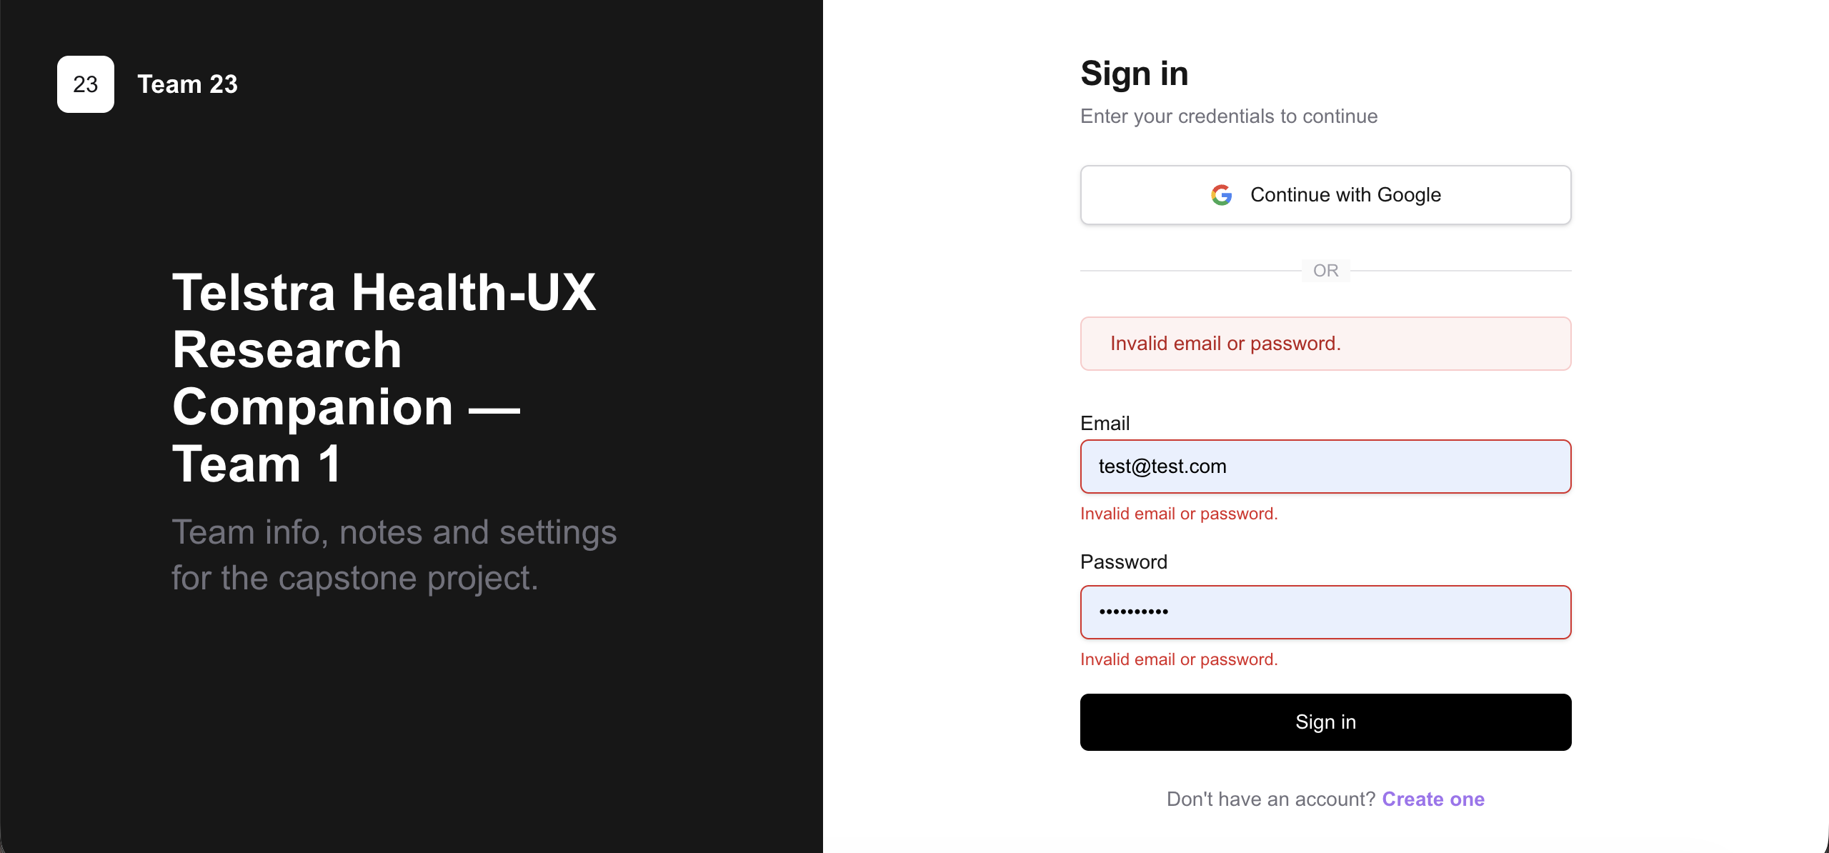

[Login Restyling Bootstrap] Task 8 — Final Review & Sign-Off
Role | PM – Ngoc Chau Vu | Date | Thursday, 13 August 2026
Completion comment
Done: Reviewed the completed feature end-to-end against the approved requirements and design, confirmed all prior tasks and checklists were completed, and provided final PM sign-off.
Deliverable: Mock Sprint Planner
Note for next role: None, the feature has been fully reviewed and approved, and the mock sprint is ready to be closed.
Git URL: https://github.com/tuanlam05/rmit-capstone/commit/b9dbe6ef8f1bee44446e500a7a1a555c24e35518

